**Mean Squared Error**

* It is simply the average of the squared difference between the target value and the value predicted by the regression model.
* MSE is ambiguous to variance
* As it squares the differences, it penalizes even a small error which leads to over-estimation of how bad the model is
* MSE is highly affected by outliers.
* Our model will also be penalized more for making predictions that differ greatly from the corresponding actual value, i.e wil have a higher MSE value
* Data having outliers value will have more mse
* Smaller the value the better the model is
* while a large MAE suggests that your model may have trouble in certain areas i.e some values are really large
* Can range from 0 to positive infinity.

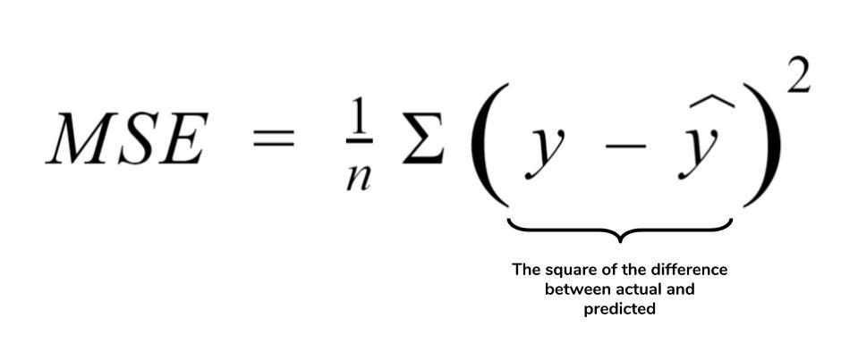

**Root Mean Squared Error**

* It is square root of the averaged squared difference between the target value and the value predicted by the model.
* Lower values of RMSE indicate better fit.
* Can range from 0 to positive infinity.
* RMSE is ambiguious to standard deviation

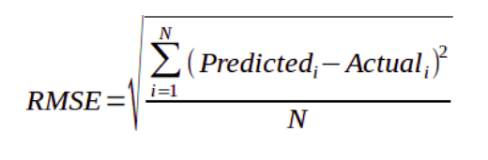

**Mean Absolute Error - MAE**

* Is the absolute difference between the target value and the value predicted by the model.
* All predictions are weighted equally
* It is not suitable for models where you want to pay more attention to the outliers.
* Can range from 0 to positive infinity.

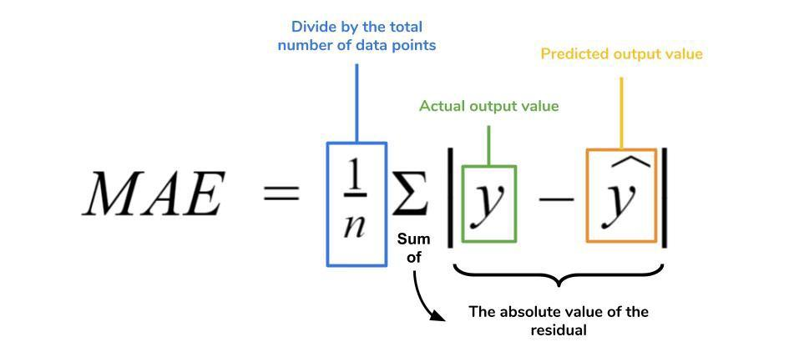

**R² Error**

* R-squared or R2 explains the degree to which your input variables explain the variation of your output / predicted variable
* If R-square is 0.8, it means 80% of the variation in the output variable is explained by the input variables.
* Higher the R squared, the more variation is explained by your input variables and hence better is your model
* Ranges from 0-1

**MSE(Baseline) = ∑(actual Y – mean value of Y)2**

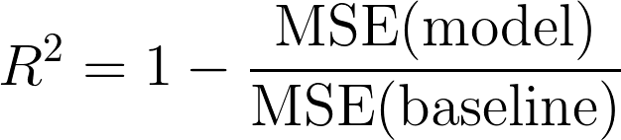

**When R² is negative**

* main reason for R² to be negative is that the chosen model does not follow the trend of the data causing the R² to be negative
* This causes the mse of the chosen model(numerator) to be more than the mse for constant baseline(denominator) (i.e the numerator is greater than the denominator resulting in negative R²

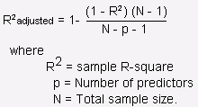

**Mean absolute percentage error**

* The mean absolute percentage error (MAPE) is the percentage equivalent of MAE.
* Get value in terms of
* Example ---- 100, 3% - 97-103

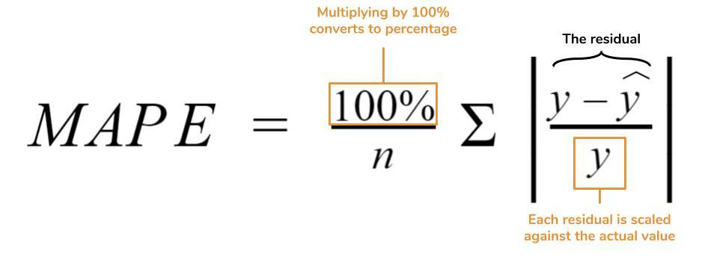

**Variance:** The average of the squared differences from the Mean.

**Standard Deviation** is just the square root of Variance,

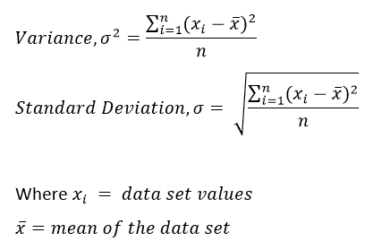

S^2 = \frac{\sum (x_i - \bar{x})^2}{n - 1}